ARRIVE Guidelines checklist

- Titel: Title page/paragraph 1/page 1
- Abstract: Abstract/paragraph 1,2,3,4/page 2
Introduction
- Background
A) Background/paragraph 2/ page 3
B) Background/paragraph 1/ page 3
- Objectives: Background/paragraph 2/page 3,4
Methods
- Ethical statement: Methods/Animals/ paragraph 1/page 5
- Study design
A) Results/ paragraph 1/page 9
B) Experimental protocol/paragraph 1/page 6/ + Histology/paragraph 1/page 12
C) Experimental protocol/paragraph 1/page 6
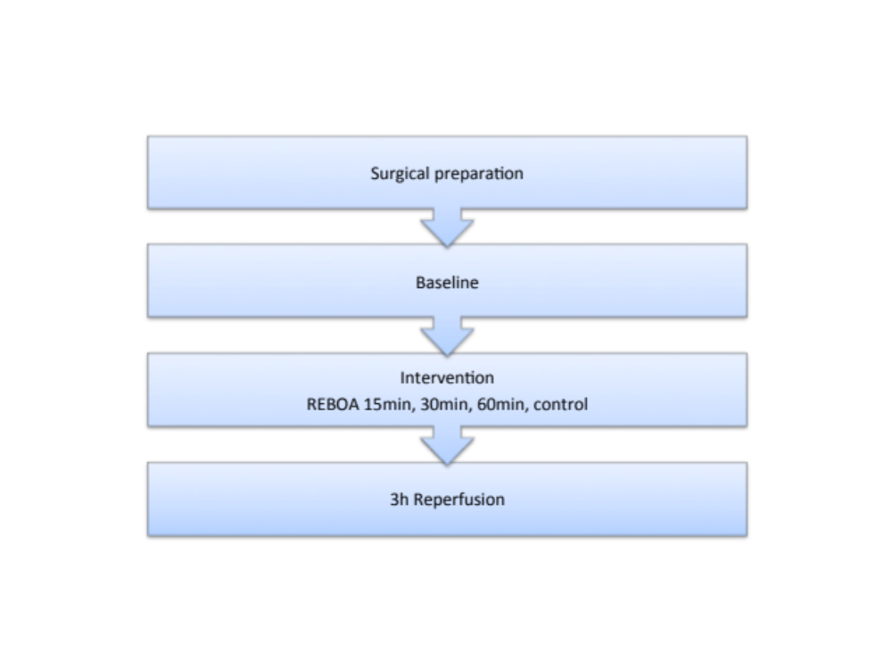
- Experimental procedures
A) Methods/Anesthesia/ paragraph 1, page 5,6
B) N/A
C) Methods/Animals paragraph 1
D) N/A
- Experimental animals
A) Methods/Animals paragraph1/page 5
B) N/A
- Housing and husbandry: N/A
- Sample size
A) Methods/Animals/paragraph 1/page 5 + Results/paragraph 1/page 9
B) Methods/Animals paragraph 1/page 5
C) N/A

- Allocating animals to experimental groups
- Methods/Experimental protocol/paragraph 1/page 6
- N/A
- Experimental outcomes: Background/paragraph 3/page 3,4
- Statistical methods
A) Statistical analysis/paragraph 1/page 8
B) Statistical analysis paragraph 1/page 8
C) N/A
Results
- Baseline data: Methods/Animals/paragraph 1/page 5
- Numbers analyzed
A) Results/paragraph 1/page 9
B) Results/paragraph 1/page 9
- Outcomes and estimation: Results/Hemodynamic and respiratory variables/paragraph 1/page 9 + systemic acid-base status and potassium/paragraph 1/page 10 + Intra-abdominal metabolism/paragraph 1,2/page 10,11, Visceral organs/paragraph1/page 11, Cytokine response/paragraph 1/page 12 + Histology/paragraph 1/page 12
- Adverse events
- Results/Hemodynamic and respiratory variables/paragraph 1/page 9 + systemic acid-base status and potassium/paragraph 1/page 10 + Intra-abdominal metabolism/paragraph 1,2/page 10,11, Visceral organs/paragraph 1/page 11, Cytokine response/paragraph 1/page 12, Histology/paragraph 1/page 12
- N/A
Discussion
- Interpretation/scientific implications
A) Discussion/paragraph 1-6, page 13-15
B) Discussion/paragraph 6/page 15
C) N/A
- Generalisability/translation: N/A
- Funding: Declarations/Funding/paragraph 1/page 18

